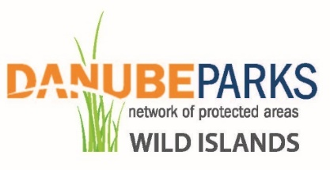
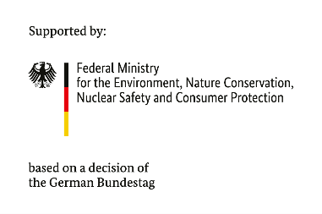
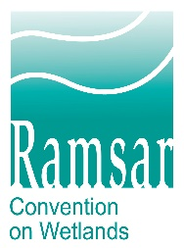

Application Guideline
DANUBE WILDisland RRI
Subgrant for practical pilot measures

Category RRI-1: „Identification, preparation, and implementation of Restoration Actions in the Danube Region“

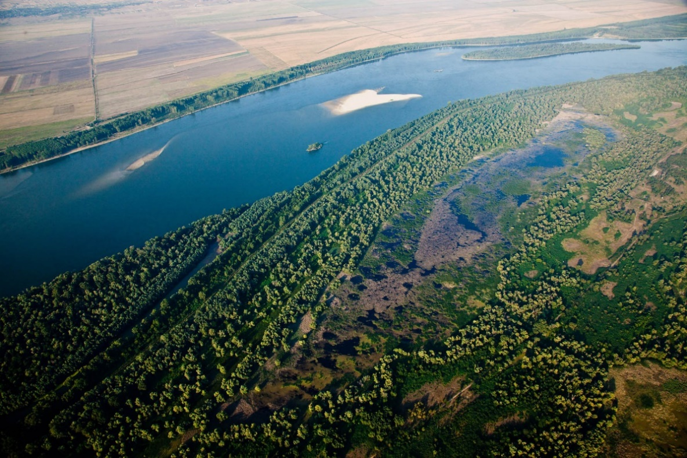
Photo credit: Wetland beside the Danube River, Persina Nature Park

- Main information
The DANUBE WILDisland RRI Subgrant for practical pilot measures was created by DANUBEPARKS – Danube River Network of Protected Areas with funding from BMUV and The Convention on Wetlands Secretariat.
The DANUBE WILDisland RRI is independently governed and does not speak or act on The Convention on the Wetlands' behalf.
The ICPDR is the formal host and non-Country member of the Danube WILDisland RRI.
The Danube WILDisland RRI is intended as the first river-focused Ramsar Regional Initiative in Europe to foster international and cross-sector cooperation and natural river and island protection, at the world´s most international river.
The Initiative is intended as a long-term collaborative effort between countries and entities for the entire Danube Basin, The Convention on Wetlands Secretariat, intergovernmental institutions, international non-governmental organizations, and national institutions specialized in wetlands issues, and finally, Danube protected areas, which aims to ensure the effective conservation of wetlands and the wise use of their resources, values, and services within the framework of the Ramsar Convention.

- Conditions for applying with project proposals

- Objective of the Subgrant provided under the Pilot Measure, Category RRI-1, and expected results:
This Pilot Measure, Category RRI-1, called for short Measure, targets the active involvement of the DANUBEPARKS Members for technical planning, execution, or monitoring of direct conservation measures, joint awareness campaigns, or small-scaled pilot actions, targeting wetlands conservation and restoration. This step is meant to provide direct financial support to DANUBEPARKS Members, thus bringing tangible benefits from their involvement in the Danube WILDisland RRI.
The results and lessons learned from the pilot measures (RRI-1 and RRI-2) will be published in a special „Practical guidelines for management & conservation measures“ which will be used by the DANUBEPARKS Members for planning and implementation of follow-up measures.
Through these pilot actions, the RRI will actively engage its member states in practical on-site activities, leading to tangible, measurable results, improving the synergy of their work, and creating a sense of community and partnership.

- Total amount of the Subgrant under the procedure:
BMUV and The Convention on Wetlands Secretariat financially support the activities under the Measure.
The total amount of funds that can be provided under the procedure through the selection of project proposals for all approved project proposals is up to EUR 36,000 including value-added tax (VAT).
DANUBEPARKS reserves the right not to provide the full amount indicated above in the case of an insufficient number of quality project proposals meeting the requirements, as well as in the case that the activities planned for implementation under the approved project proposals under the procedure require smaller financial resources.
DANUBEPARKS reserves the right not to provide Subgrant aid for project/s proposals if, during a check by DANUBEPARKS for compliance with the eligibility requirements of the pilot measure, violations of the assessed project proposals are found.

- Minimum and maximum amount of grant for a specific project:
The procedure does not provide for a minimum grant amount for a project proposal.
The maximum amount of eligible costs for which a Subgrant may be provided for each project proposal includes all eligible costs for the implementation of the project and is EUR 12,000.

- Co-financing rate
The procedure can provide co-financing up to 100% of the eligible costs.
Co-financing (own participation) by the applicants is permissible without limitation of its share.
Projects that generate revenue will not be financed under the procedure.

- Eligible candidates
Eligible applicants are full members of the DANUBEPARKS. According to the DANUBEPARKS Statutes (5.6): „Full members are legal entities that are responsible for the management of one, large parts of one, or several, Protected Area(s) along the Danube River or one of its main tributaries. They support the goals of the DANUBEPARKS Network, commit themselves to participate in joint activities, and pay membership fees. Full members need to have passed at least one year as an Observer to DANUBEPARKS before having the right to apply for Full membership (at the exception of the founding members of DANUBEPARKS).“
Observers and Supporting members of DANUBEPARKS, or any other external entities are not eligible applicants.

- Activities eligible for funding
The activities envisaged for implementation within the framework of the project proposal should comply with the principles of effectiveness, efficiency, and economy, be of a non-profit nature, and lead to the achievement of the objectives of the procedure, following the principle of "doing no significant harm" and with the principles of equality between women and men and ensuring equal opportunities for all.
6.1. The following types of activities and costs are eligible for funding under the procedure:
The Measure supports the development of essential work needed to prepare the wetland/s restoration projects. This may include activities such as:
- feasibility studies;
- preparing technical design documents;
- securing necessary permissions and permits;
- joint monitoring programs for relevant species and habitats;
- engaging the local community and other relevant stakeholders in the planning of the future restoration projects;
- implementation of the small-scale pilot actions.

  - Types of ineligible costs
Ineligible project costs include but are not limited to:
- Staff costs (all categories, incl. bonuses);
- Land purchase;
- Construction costs;
- Fixed assets (e.g. equipment) over EUR 3 500,00 per item;
- The Measure cannot supplement ongoing activities and finances from existing programs, projects, resources, or personnel. If a part of the project activities is not covered by the Measure, co-financing from another source is possible.
- Personal injury compensation or damages;
- Fines and penalties;
- Costs outside the scope of the approved project or activities not directly related to the approved project;
- Costs incurred outside the Subgrant period.

- Minimum and maximum project implementation period:
The maximum period for implementation of the project activities, which the beneficiary can indicate in the application form is 18 months, but no later than 31.12.2026.

- Procedure for evaluating project proposals. Criteria and methodology for the evaluation of project proposals.
The evaluation is carried out based on the methodology and criteria included in these guidelines and they are not subject to change during the evaluation.
A specific beneficiary may submit only one project proposal under the measure.
The evaluation of the project proposals is carried out by the Evaluation Committee.
Project proposals submitted within the application period will be evaluated in 3 separate categories, depending on the location of the applicant. The categories are as follows:
- Upper Danube – Germany, Austria, Slovakia
- Middle Danube – Hungary, Croatia, Serbia
- Lower Danube – Romania, Bulgaria, Moldova
In each category, project proposals will be ranked in descending order based on the final number of points received at the technical evaluation stage.
The ranking intends to identify at least 3 projects approved for funding – the first one from each of the categories.
But, if no project proposal is submitted in some of the categories, there will be no funding for this category and the funds will be directed to projects from the other categories, starting with the second one receiving a higher number of points.
Also, if 3 project proposals (from all categories) are approved and there are residual funds, they will be directed, according to the evaluation of the project proposals.
IMPORTANT: In case of projects with an equal number of points obtained because of the technical evaluation, for which there is insufficient financial resource, the following conditions will be applied sequentially only for these projects:
These projects will be additionally prioritized/ranked under Criterion 1 “The candidate has described in detail, clearly and logically the need to implement the activities (who, where, when and how will carry out the activities)”
Additional points under the criterion will not be awarded to the project proposal.
In case the project proposals have an equal number of points in Criterion 1, priority in the ranking of the approved projects will be given to project proposals with less amount of eligible costs.

In cases of irregularities, incompleteness, and/or inconsistencies in the project proposal identified during the evaluation process, the Evaluation Committee sends a request to the applicant (via email). The applicant has the right to respond within 1 week and bring their project proposal into compliance with the requirements.
In case the specific beneficiary does not eliminate the irregularity, incompleteness, and/or non-compliance with the requirements within the deadline and/or does not request an extension Evaluation Committee sends a second notification (with a response deadline of 1 week). If the irregularities are not eliminated after the second communication, the procedure concerning this candidate is terminated.
The Evaluation Committee will then select the best applications and distribute the funding following the signing of individual Subgrant Contracts with reporting obligations. There will be a deliberate attempt to prioritize partners, who have no ongoing projects with DANUBEPARKS and provide a fair distribution among Upper-Middle-Lower Danube states. This will guarantee a fair and transparent selection process, easy to follow and report.
  - Administrative compliance and eligibility
The evaluation includes an assessment of administrative compliance, eligibility, and quality. It is checked whether the project proposal meets all the criteria, with each criterion being assessed as "YES", "NO" or "NOT APPLICABLE" (NA).
If a final assessment of "NO" is received for a given criterion and the project proposal cannot be brought into line with the measure within the specified deadline, it is not proposed for funding and the procedure is terminated for the specific beneficiary.
№ | Criterion | YES/  NO/ NA | Assessment methodology
1. | The candidate has submitted all documents required for the application, and the documents indicated have been signed. |  | A check is being carried out for compliance with the documents.
2. | The candidate is eligible according to the application conditions. |  | A compliance check is carried out on the information with the requirements and conditions of the "Eligible Candidates" section of the application conditions.
3. | The activities/costs for which funding is requested from the program are eligible according to the application conditions. |  | A check is carried out on the compliance of the activities included in the project with the instructions in the section "Activities eligible for funding" of the application conditions.

  - Technical evaluation
Technical evaluation is an evaluation of the merits of the project proposals. The technical and financial evaluation is carried out by assigning points to each of the sub-criteria. When the conditions for awarding the specified number of points are not met for a given criterion, 0 points are awarded when evaluating the criterion. The sum of the points from the relevant sub-criteria gives the points for the criterion. The results thus obtained for each criterion separately are added up and form the result of the technical and financial evaluation of the project proposal. Based on the total number of points, the project proposals are ranked in descending order.
№ | Criterion | Assessment methodology
1. | The candidate has described in detail, clearly and logically the need to implement the activities (who, where, when, and how will carry out the activities) | For activity "Feasibility studies" – 3 points  For activity "Preparing of technical design documents" – 3 points  For activity "Securing necessary permissions and permits" – 3 points  For activity "Joint monitoring programs for relevant species and habitats" – 3 points  For activity "Engaging the local community and other relevant stakeholders in the planning of the future restoration projects" – 3 points  For activity "Implementation of the small-scale pilot actions" – 3 points  Maximum number of points from Criterion – 18 points.
2. | The planned activities contribute to the implementation of the project objectives | For all activities – 6 points.  For each of the activities - 1 point.  Maximum number of points from Criterion – 6 points.
3. | The envisaged activities contribute to the implementation of the objectives of the Measure | For all activities – 6 points.  For each of the activities - 1 point.  Maximum number of points from Criterion – 6 points.
4. | The candidate will continue with the activities after the end of the Measure. | Well-explained potential sources of funding - 3  Well-explained plan for involvement of key stakeholders – 3  Maximum number of points from Criterion – 6 points.
5. | The candidate has no ongoing project/s with DANUBEPARKS | If the candidate has no ongoing project/s with DANUBEPARKS - 3 points.  If the candidate has ongoing project/s with DANUBEPARKS – 0 points.  Maximum number of points from Criterion – 3 points.

The maximum number of points a project proposal can receive is 39.

- How to submit project proposals
Applications are submitted through the online form available at: https://forms.gle/aB3biZLeetdvJqbh9

- List of documents to be submitted at the application stage
  - Application Form – Mandatory
  - Project Budget – Mandatory
2 files must be uploaded to Section “Breakdown of Costs”, online Application Form, using the template "RRI-1_Project Budget_XXXX":
- A Microsoft Excel file;
- A .pdf file, dated and signed by the Official Representative of the Organization.

  - Other documents related to the evaluation of the project proposal and helping to justify the need to implement the project proposal - Optional

- Deadline for submitting project proposals
Candidates may submit project proposals before the deadline, which is: 03.03.2025, 17:00 CET

- DANUBEPARKS contacts
For additional explanatory information regarding the Application Guideline and/or filling out the Application Form, as well as other matters concerning the Measure, please contact us via the following emails:
persina@danubeparks.org
office@danubeparks.org

Regional Ramsar Initiative
Federal Ministry for Environment, Nature Conservation, Nuclear Safety and Consumer Protection, Germany
International Commission for the Protection of the Danube River

