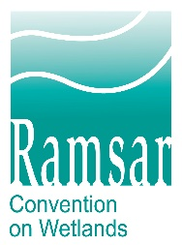
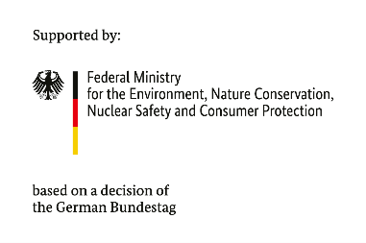
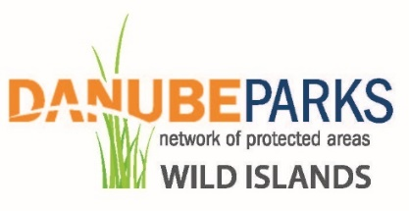

Application Guideline
DANUBE WILDisland RRI
Subgrant for practical pilot measures

Category RRI-2: „Awareness-raising events for the Danube WILDisland RRI“

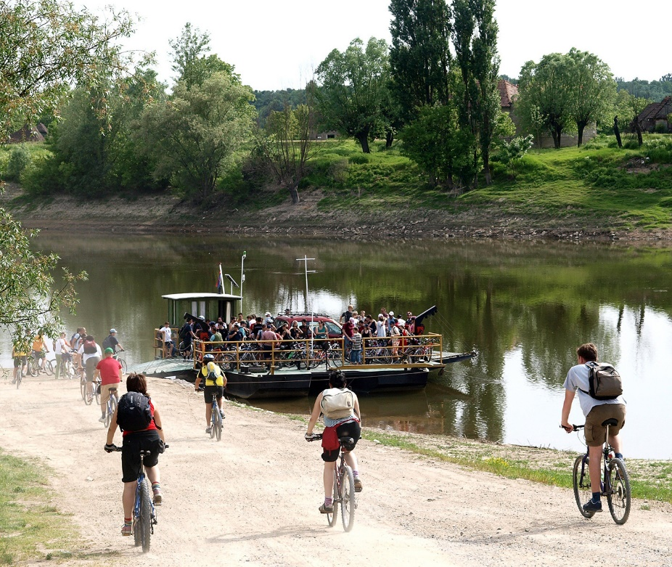
Photo credit: Lonjsko Polje Nature Park

- Main information
The DANUBE WILDisland RRI Subgrant for practical pilot measures was created by DANUBEPARKS – Danube River Network of Protected Areas with funding from BMUV and The Convention on Wetlands Secretariat.
The DANUBE WILDisland RRI is independently governed and does not speak or act on The Convention on the Wetlands' behalf.
The ICPDR is the formal host and non-Country member of the Danube WILDisland RRI.
The Danube WILDisland RRI is intended as the first river-focused Ramsar Regional Initiative in Europe to foster international and cross-sector cooperation and natural river and island protection, at the world´s most international river.
The Initiative is intended as a long-term collaborative effort between countries and entities for the entire Danube Basin, The Convention on Wetlands Secretariat, intergovernmental institutions, international non-governmental organizations, and national institutions specialized in wetlands issues, and finally, Danube protected areas, which aims to ensure the effective conservation of wetlands and the wise use of their resources, values, and services within the framework of The Convention on Wetlands Secretariat.

- Conditions for applying with project proposals

- Objective of the Subgrant provided under the Pilot Measure, Category RRI-2, and expected results:
This Pilot Measure, Category RRI-2, called for short Measure, targets the active involvement of various entities from the DANUBEPARKS Members for implementation of promotion and visibility actions in DANUBEPARKS protected areas – develop relevant communication tools and materials in various languages to increase the visibility and recognition of the RRI and promote the aims and practical work on wetlands conservation, as well as candidates’ unique ecosystem services and functions. This step is meant to provide direct financial support for organizations from the DANUBEPARKS Members, thus bringing tangible benefits from their involvement and membership in the WILDisland RRI.
This measure also funds common information and awareness campaigns, such as World Wetlands Day, Danube Day, or other celebrations according to the applicant's event calendar that meet the objectives of the Measure.

The results and lessons learned from the pilot measures (RRI-1 and RRI-2) will be published in a special „Practical guidelines for management & conservation measures“ which will be used by the DANUBEPARKS Members for planning and implementation of follow-up measures.
Through these pilot actions, the RRI will actively engage its member states in practical on-site activities, leading to tangible, measurable results, improving the synergy of their work, and creating a sense of community and partnership.

- Total amount of the Subgrant under the procedure:
T BMUV and The Convention on Wetlands Secretariat financially support the activities under the Measure.
The total amount of funds that can be provided under the procedure through the selection of project proposals for all approved project proposals is up to EUR 20,000 including value-added tax (VAT).
DANUBEPARKS reserves the right not to provide the full amount indicated above in the case of an insufficient number of quality project proposals meeting the requirements, as well as in the case that the activities planned for implementation under the approved project proposals under the procedure require smaller financial resources.
DANUBEPARKS reserves the right not to provide Subgrant aid for project/s proposals if, during a check by DANUBEPARKS for compliance with the eligibility requirements of the pilot measure, violations of the assessed project proposals are found.

- Minimum and maximum amount of grant for a specific project:
The procedure does not provide for a minimum grant amount for a project proposal.
The maximum amount of eligible costs for which a Subgrant may be provided for each project proposal includes all eligible costs for the implementation of the project and is EUR 1,000.
The amount includes necessary event-based costs related to Wetlands Day in 2026 and 2027.
And costs related to 3 more events. For example, for the celebration of Danube Day or any other celebration according to the event calendar of the candidate. The events could be for the same or different celebrations. They should start in 2025 and end no later than 30.09.2027. It is also possible that all 3 events start and end in one or two years.
The costs for each event cannot exceed EUR 200,00.

- Co-financing rate
The procedure can provide up to 100% of the maximum amount of eligible costs.
Co-financing (own participation) by the applicants is permissible without limitation of its share.
Projects that generate revenue will not be financed under the procedure.

- Eligible candidates
Eligible applicants are full members of the DANUBEPARKS. According to the DANUBEPARKS Statutes (5.6): „Full members are legal entities that are responsible for the management of one, large parts of one, or several, Protected Area(s) along the Danube River or one of its main tributaries. They support the goals of the DANUBEPARKS Network, commit themselves to participate in joint activities, and pay membership fees. Full members need to have passed at least one year as an Observer to DANUBEPARKS before having the right to apply for Full membership (at the exception of the founding members of DANUBEPARKS).“
Observers and Supporting members of DANUBEPARKS, or any other external entities are not eligible applicants.

- Costs eligible for funding
The Measure supports all direct costs related to the event organization. It could include:
- materials that will be tailored to the individual needs of the members of the DANUBEPARKS (flyers, stickers, posters, etc.) and will address different target groups, where gaps of knowledge or target interest have been identified (wide public, experts, potential partners, etc.)
- event catering
- transportation costs
- materials for volunteers
- other costs according to the event that are not staff costs or indirect costs
It is necessary for every project proposal to include the Regional Ramsar Initiative in the events. The candidate decides which is the most appropriate way to do this according to his project proposal and describes it in the Application Form.

- Minimum and maximum project implementation period:
The maximum period for implementation of the project activities, which the beneficiary can indicate in the application form is no later than 30.09.2027.

- Procedure for evaluating project proposals. Criteria and methodology for the evaluation of project proposals.
The evaluation is carried out based on the methodology and criteria included in these guidelines and they are not subject to change during the evaluation.
A specific beneficiary may submit only one project proposal under the measure.
The evaluation of the project proposals is carried out by the Evaluation Committee.
In cases of irregularities, incompleteness, and/or inconsistencies in the project proposal identified during the evaluation process, the Evaluation Committee sends a request to the applicant (via email). The applicant has the right to respond within 1 week and bring their project proposal into compliance with the requirements.
In case the specific beneficiary f does not eliminate the irregularity, incompleteness, and/or non-compliance with the requirements within the deadline and/or does not request an extension Evaluation Committee sends a second notification (with a response deadline of 1 week). If the irregularities are not eliminated after the second communication, the procedure concerning this candidate is terminated.
The Evaluation Committee will then select the best applications and distribute the funding following the signing of individual Subgrant Contracts with reporting obligations.
Administrative compliance and eligibility
The evaluation includes an assessment of administrative compliance, eligibility, and quality. It is checked whether the project proposal meets all the criteria, with each criterion being assessed as "YES", "NO" or "NOT APPLICABLE" (NA).
If a final assessment of "NO" is received for a given criterion and the project proposal cannot be brought into line with the measure within the specified deadline, it is not proposed for funding and the procedure is terminated for the specific beneficiary.
№ | Criterion | YES/  NO/ NA | Assessment methodology
1. | The candidate has submitted all documents required for the application, and the documents indicated have been signed. |  | A check is being carried out for compliance with the documents.
2. | The candidate is eligible according to the application conditions. |  | A compliance check is carried out on the information with the requirements and conditions of the "Eligible Candidates" section of the application conditions.
3. | The costs for which funding is requested from the program are eligible according to the application conditions. |  | A check is carried out on the compliance of the activities included in the project with the instructions in the section "Costs eligible for funding" of the application conditions.

- How to submit project proposals
Applications are submitted through the online form available at: https://forms.gle/JEsppyg6wVL9crGy8

- List of documents to be submitted at the application stage
  - Application Form – Mandatory
  - Project Budget – Mandatory
2 files must be uploaded to Section “Breakdown of Costs”, online Application Form, using the template "RRI-2_Project Budget_XXXX":
- A Microsoft Excel file;
- A .pdf file, dated and signed by the Official Representative of the Organization.

  - Other documents related to the evaluation of the project proposal and helping to justify the need to implement the project proposal - Optional

- Deadline for submitting project proposals
Candidates may submit project proposals before the deadline, which is: 03.03.2025, 17:00 CET

- DANUBEPARKS contacts
For additional explanatory information regarding the Application Guideline and/or filling out the Application Form, as well as other matters concerning the Measure, please contact us via the following emails:
persina@danubeparks.org
office@danubeparks.org

Regional Ramsar Initiative
Federal Ministry for Environment, Nature Conservation, Nuclear Safety and Consumer Protection, Germany
International Commission for the Protection of the Danube River

