
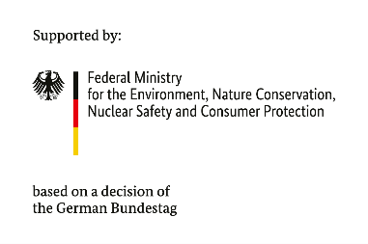


Conditions for implementation of approved projects
DANUBE WILDisland RRI
Subgrant for practical pilot measures

Category RRI-2: „Awareness-raising events for the Danube WILDisland RRI“

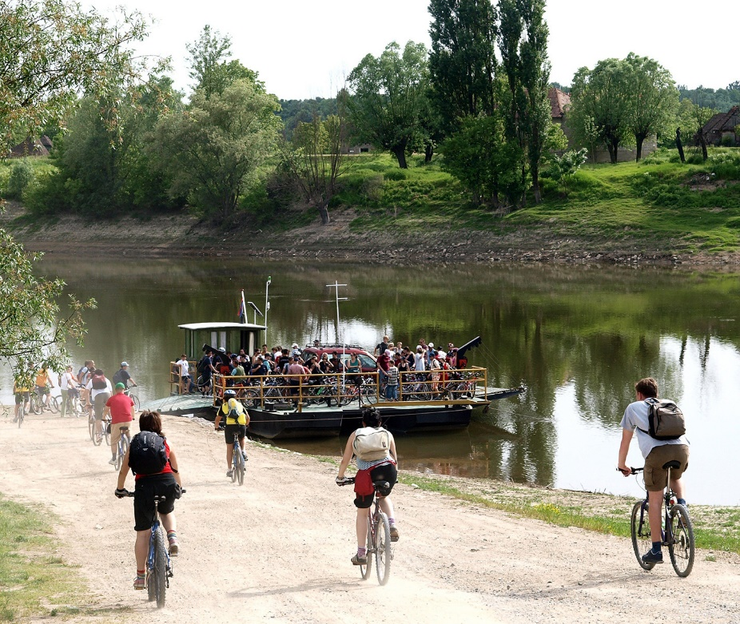
Photo credit: Lonjsko Polje Nature Park

The implementation of the approved projects starts immediately after the signing of the Subgrant Contract between the beneficiary and DANUBEPARKS.

By signing, both sides accept the following conditions:

- Beneficiary obligations

- The beneficiary accepts all the Conditions for implementation of approved projects, according to the Application Guideline of the Measure, including:
  - to implement the Project in the way, to the extent, and within the timeframe specified in the Project Proposal and Project Budget.
  - to use the funds earmarked for the Project, i.e. the Subgrant, the beneficiary’s resources, and any contribution granted by third parties, according to the Project Proposal (incl. Project Budget) and exclusively for the purposes set out therein.
  - to reimburse without delay upon request
  - the unused parts of the claimed Subgrant to which the beneficiary is not entitled according to this Subgrant Contract as soon as the overpayment becomes apparent.
  - the Subgrant or parts thereof if they are not used by the objectives of the Project or if other provisions of the present Subgrant Contract have been infringed.
  - any interest accrued by the beneficiary on the Subgrant.
  - to submit to the Donor within 15 days after completion of the Project, at the latest by 15.10.2027, the Final Report;
  - to draft the report using the template provided by DANUBEPARKS.
  - to confirm in its Final Report that
- all financial transactions have been made by the Project Proposal, the Project Budget, and the intended purpose of the Subgrant.
- the Subgrant was examined by comprehensive internal control procedures based on the financial regulations, rules, and directives currently applicable to the beneficiary.
  - to keep the original receipts (receipts for income and expenditure) for the individual payments and the agreements concerning the awarding of contracts as well as all other documents relating to the Subgrant for five years after submission of the Final Report, unless a

longer compulsory period of record-keeping is stipulated by the tax laws or other legal provisions applicable to the beneficiary.
  - to provide the Donor with additional information on the Project at any time upon request within 10 days after receipt of the notification.
  - to allow the Donor and third parties contracted by the Donor to examine whether the Subgrant has been used for the intended purpose, as outlined in the Project Proposal and Project Budget, and by the principles of efficiency and effectiveness. In addition, the beneficiary must maintain financial records, supporting documents, statistical records, and all other records relevant to the Project by generally accepted accounting principles to sufficiently substantiate all expenditures and administration fees of whatever nature involving transactions related to the funds provided by the Donor under this Subgrant Contract.
  - to inform the Donor without delay and in writing of:
- any additional funding the beneficiary applies for or receives for the implementation of the Project after this Subgrant Contract has entered into force.
- any Significant Deviation from or changes to the Project Proposal.
- the inability to utilize the claimed or disbursed Subgrant for due payments.
- bankruptcy or similar proceedings which have been applied for or initiated against the property of the beneficiary.
- any circumstances which prevent the Subgrant or parts thereof from being used for the intended purpose.

- The beneficiary has the right:
  - to receive a Subgrant by the procedure, within the terms and conditions set out in the Subgrant Contract.
  - to be notified in advance of the dates of the planned on-site inspections.
  - to be notified in writing of the amount of verified costs included in payment requests.
  - to receive from DANUBEPARKS documents and information regarding the requirements relating to the provision of a Subgrant under the Measure.

- Beneficiary reporting
  - The beneficiary shall be responsible for the implementation of the project and shall be liable for the accuracy and completeness of the information provided by him. The beneficiary shall always provide additional information and documents requested by DANUBEPARKS regarding the implementation of the project.
  - The beneficiary shall comply with all guidelines, guidelines, instructions and other horizontal documents approved by DANUBEPARKS, related to the implementation of the Measure.

- DANUBEPARKS obligations
- to provide the beneficiary with the Subgrant under the conditions and within the time limits set out in the Subgrant Contract.
- to notify the beneficiary of the dates of the planned on-the-spot checks within a reasonable time.
- to notify the beneficiary in writing of the amount of verified and unverified expenditure included in the payment requests, as well as of amounts intercepted and/or temporarily or conditionally retained.
- to provide the beneficiary, upon request, with documents and information regarding the requirements relating to the provision of the Subgrant under the Measure.

- DANUBEPARKS rights
- to verify the beneficiary's compliance with its obligations under the Subgrant Contract.
- to carry out checks on the documentation provided by the beneficiary.
- to carry out on-the-spot checks of the beneficiary.
- to verify the beneficiary's compliance with recommendations and instructions contained in on-the-spot checks and audit reports.
- to request information and documents from the beneficiary related to the implementation of the Subgrant Contract.
- to request the reimbursement of amounts due to irregularities and other amounts unduly paid and overpaid, funds wrongly received or misappropriated.
- to determine and implement financial corrections.
- to give instructions that are binding on the beneficiary about the implementation of the Subgrant Contract.
- to terminate the Subgrant Contract if there are grounds provided for therein and/or in the current legislation.
- DANUBEPARKS, BMUV, and The Convention on Wetlands Secretariat have the right to publish the name and address of the beneficiary, the name of the project, and the amount of the Subgrant provided.

- Eligible costs for reimbursement
Only eligible costs incurred by the beneficiary (including its partner) are eligible for reimbursement. Eligible costs are those that comply with the eligibility requirements set out in the applicable European and national legislation and these implementing conditions.
Ineligible costs approved and paid by the beneficiary remain at its expense and are not eligible for reimbursement and financing through the Subgrant.

- Verification of expenses
Only costs for which eligibility requirements have been met are subject to verification.
Management checks for verification of expenditure include:
- documentary verification of each payment request submitted by the beneficiary, including the accompanying documentation.
- on-the-spot checks of the beneficiary, including at the place of implementation of the project, financial intermediaries or final recipients, and partners of the beneficiary, where applicable, at the discretion of DANUBEPARKS
DANUBEPARKS may request additional documents and explanations from the beneficiary during the verification.
Invoices and accounting documents of equivalent probative value should contain the following details: the name of the Measure, as well as the number and date of the contract for the implementation of the activities under the project.
In case the verification of the relevant expense cannot be carried out with an invoice, the expenditure shall be proven with:
a) a document with an equivalent probative value to an invoice - documents that are issued in the presence of the following cumulative circumstances:
b) another expenditure justification document with probative value within the meaning of the national/European legislation.

- Payments to the beneficiary
- Payment types
The Subgrant is provided to the beneficiary in the forms provided for in the Subgrant Contract and in compliance with the current legislation.
DANUBEPARKS makes payments to the beneficiary within the limits set by the support of BMUV and The Convention on Wetlands Secretariat.

DANUBEPARKS pays to the beneficiary 75% of the approved Project Budget after the Subgrant Contract enters into force.
DANUBEPARKS is going to pay the beneficiary the rest of the expenses incurred according to the approved Project Budget after receiving and approving the Final Report. The final payment cannot exceed 25% of the Project Budget.

- Procedure for reimbursement of irregular expenses
The beneficiary is obliged to reimburse DANUBEPARKS the Subgrant provided when:
- an individual financial correction is determined.
- an amount unduly paid or overpaid, as well as an amount unlawfully received or unlawfully utilized, is established.
The beneficiary is obliged to reimburse DANUBEPARKS the amount of the advance payment provided when it is established that the funds provided are not spent on making payments under the project and/or that they are used to finance ineligible costs.

- Subgrant Contract amendment
The concluded Subgrant Contract may be amended by an additional written agreement in the part of the provided value of the Subgrant when it exceeds the maximum value specified in the conditions for application, subject to available financial resources and following a Decision of DANUBEPARKS.
The request for an extension must be motivated and accompanied by all evidence of the existence of the circumstances necessitating the extension.

- Termination of the Subgrant Contract
DANUBEPARKS may unilaterally terminate the Subgrant Contract to prevent or eliminate serious consequences for the public interest.
The Subgrant Contract may be terminated because of a request submitted by the beneficiary.
Upon termination of the Subgrant Contract DANUBEPARKS has the right to request the beneficiary to reimburse all funds paid under the Subgrant Contract within a period specified by DANUBEPARKS, together with the interest due, which is accrued from the moment the obligation becomes due.

- Final provisions
By signing the Subgrant Contract, the beneficiary agrees to have his/her data stored and processed by DANUBEPARKS.
The exchange of information between the beneficiary and DANUBEPARKS is carried out via the official e-mail address specified in the Application Template.
The correspondence contains the project number, the Subgrant Contract number, and the full name of the project.
DANUBEPARKS and the beneficiary undertake to comply with the applicable international and national legislation.
If any of the clauses of these performance conditions are declared null, invalid, or unenforceable in whole or in part by a regulatory, administrative, or judicial act, this clause will not apply, without affecting the validity and/or applicability of the remaining part of the performance conditions.

